**SUSEFA**

***About us***

Sustainable energy foundation Africa is an International NGO registered in Kenya. It has its headquarters in Nairobi. SUSEFA promotes renewable energy access and energy efficiency for environmental sustainability and betterment of lives.

***Vision***

To enrich lives in Africa through facilitating renewable energy access, efficient energy use and environmental sustainability.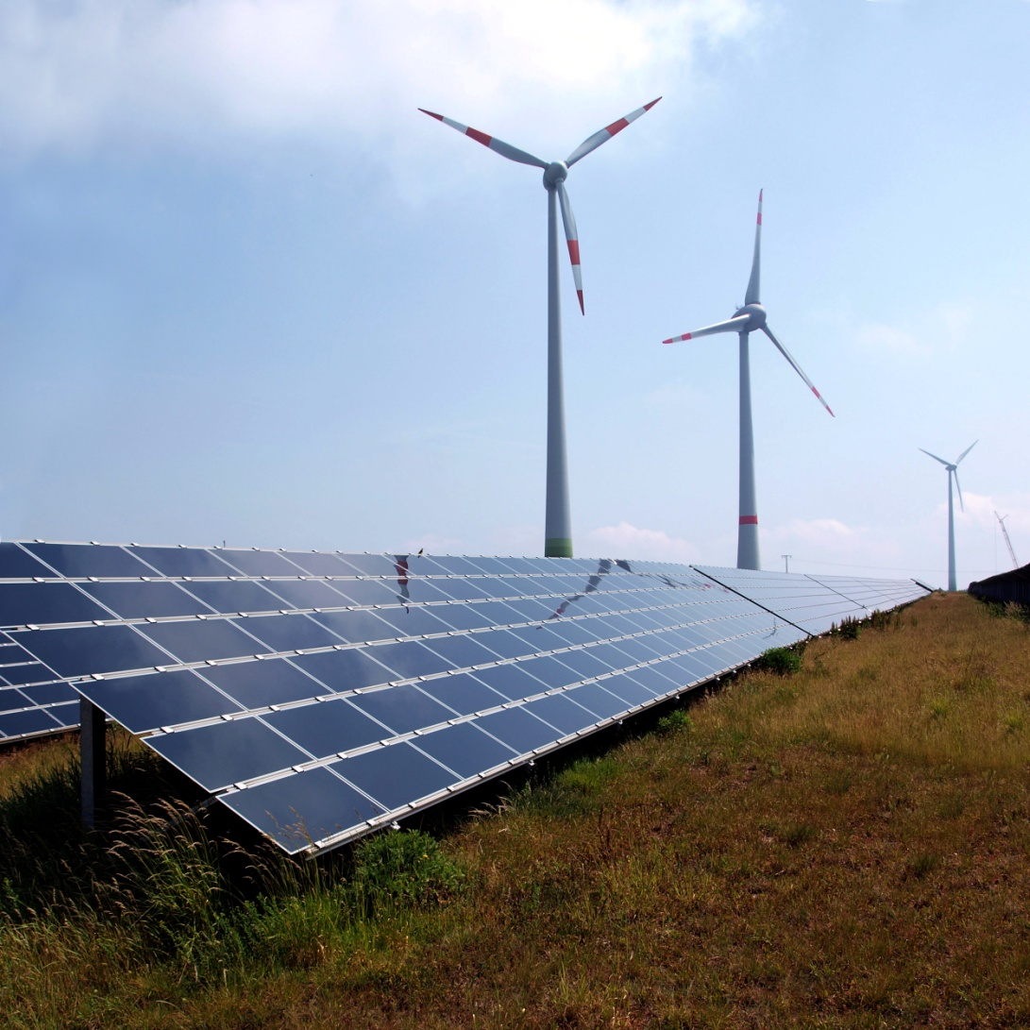

***Mission Statement***

SUSEFA seeks to promote sustainable living through societies founded on the efficient use of energy and other resources. Our focus is mainly capacity building in policy and project development at all spheres of government, promoting sustainable strategies, planning and implementation initiatives and implementing practical examples of sustainability thus, promoting the uptake of renewable energy and sustainable energy utilization in Africa.

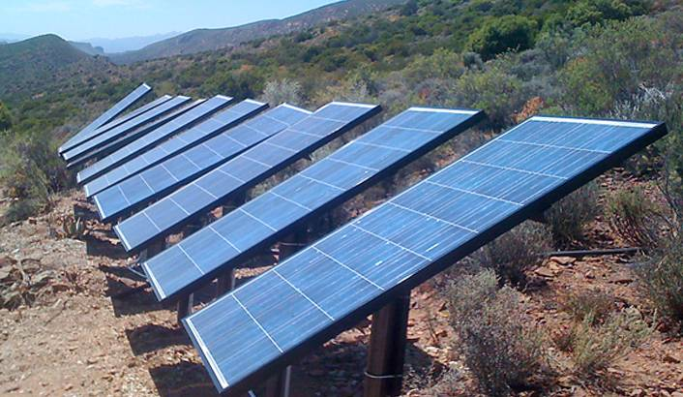

***Core Values:***

* *Resource efficiency*
* *Community ownership*
* *Integrity*
* *Professionalism*
* *Scalability*

***Background***

Energy access is a prerequisite for development. Indeed, energy is all about education, better health, equality, security and economic development. Children can spend less time on domestic chores and more time in schools instead. Also, they can study after dark and have access to information i.e. TV, radio and computers. Clinics can stay open for longer and offer better services. Access to modern energy forms creates opportunities for women and girls in form of extra time as they can attend school and pursue work and goals outside home. Energy creates opportunities for people to create businesses, earn a living and feed their families.

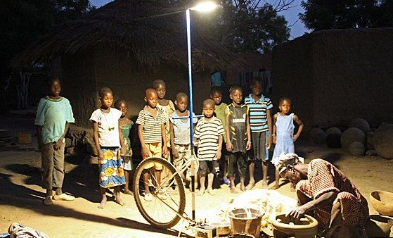

Street-lighting offers a chance for economic expansion, since businesses can sell their wares at night. Women are more likely to frequent these businesses since it will be safer for them to leave their homes at night.

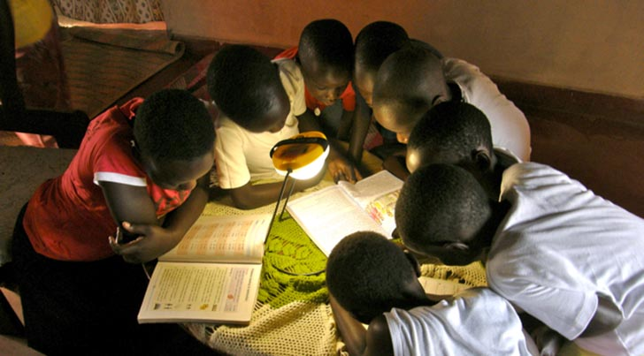

Unfortunately, a vast majority of the population in Sub-Saharan Africa lack access to electricity and clean cooking fuels. Many deaths are linked to indoor air pollution in households using wood, biomass and coal cooking stoves. This has inspired SUSEFA to help make energy accessible to all in Africa.

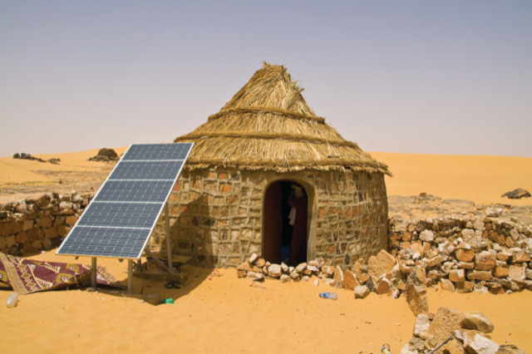

***Focus /Areas of work***

SUSEFA's main areas of work include:

* Energy policy and strategy development
* Climate change strategy development
* National and local integrated energy planning
* Cleaner industrial production and energy audits
* Eliminating energy poverty by promoting energy access for all
* Sustainable energy education and training
* Solar/wind irrigation for climate smart agriculture
* Sustainable transportation
* Energy research and publications
* Efficient energy use training and advocacy-awareness
* Green buildings and sustainable commercial building development
* Renewable energy and energy efficiency
* Sustainable and holistic urban futures including transport sustainability
* Promoting a low carbon future for cities and communities and rural villages

***Organizational Structure***

***Board***

SUSEFA has a board of directors, who meet at least once a year at an annual general meeting (AGM), but also at extraordinary meetings if particular issues need to be discussed with them. They assist in seminars or meetings during the course of the year as requested or required. The Board membership and selection is decided upon at the annual general meeting.

The board consists of five members as listed below:

1. Japheth Omari – Chairman

Japheth holds a Bsc (Electrical Engineering Degree- UoN) and has vast experience in electrical energy distribution and transmission, renewable energy, energy efficiency and climate change.

1. Evans Onchonga – Secreatary

Evans holds a Bsc (Civil and Structural Engineering- UoN) and has great experience in the construction industry, green buildings, sustainable urban development, project management and Wind/Solar Energy application in irrigation systems.

1. Larvinia Onduko – Treasurer

Larvinia holds a MSc (Mobile Telecommunications and Innovation- Strathmore) and Bsc (Information Technology-MMU). She comes with a wealth of experience in incorporating ICT tools in agriculture programmes for farmers in bid to enhance crop productivity, curbing wastage in storage and transportation to markets. She is the Team Leader and Lead Developer Mkulima App an award winning application targeting farmers in Kenya.

1. Phyllis Ogwora – Member

Phyllis holds a Bsc (Actuarial Science-UoN) and has a wealth of experience in investment risks assessment in development projects having worked for Old Mutual and handled projects from AfDB and World Bank

1. Douglas Makori – Member

Douglas hold a Bsc (Surveying- UoN) and has vast experience in mega energy projects having been a project Surveyor at the Sondu-Miriu Hydro-Power Project in Kenya. Also, he has project management, urban planning and county governance experience.

SUSEFA operates in a transparent and inclusive manner in terms of decision making and the development of organizational policies. The organization has a management committee which is comprised of the two directors, and the lead project coordinator. The management committee meets once a month to discuss staffing and organizational issues, including policy development, finances, funding, management matters and marketing.

The directors meet on a regular basis and oversee the full running of the organization.

***Governance***

SUSEFA is very aware of the need for transparency and scrupulous financial policies and practices in today’s environment. To this end, it has spent a considerable amount of effort and time in developing procedures that ensure financial responsibility is shared and divided among the management of the organization. Clear separation of responsibilities has been implemented. All project finances are authorized against budgets by the project managers, overheads are controlled by the office manager and directors, again against clear budgets. Monies are only released after three separate steps, always including a director, almost exclusively through Internet banking. Monthly financial reports are scrutinized by the managing director before proceeding to the management committee for formal adoption. A full audit is undertaken on an annual basis.

SUSEFA's policies, both financial and administrative, are reviewed regularly and adjusted as the need arises. They are also reviewed by its auditors. The administrative department ensures that policies are adhered to and maintained and they keep records relating to leave, salaries and general human resource issues. Life cycle salary records are maintained and authorized by both staff member and directors.

***Internal Organization Learning and Development***

SUSEFA recognizes that many of the current working norms in the African economies have roots dating back to the colonial era and are not necessarily 'human-friendly,' for instance, they are not conducive to individual happiness nor well-being in society in general. Among these, are spending long hours and one's best energy at work, leaving little over for important functions such as leisure, family, personal growth and community, as well as removing parents from children for most of the day to go to work. While these are widely accepted practices, their serious negative impact on individuals and society is increasingly being recognized and measures are being adopted by more and more corporations around the world to change this.

As part of SUSEFA's commitment to being socially responsible and promote sustainable living, the organization has become proactive in this area too, and has instituted various measures in this regard, including a seven-hour work day, a 'Happiness Index' to keep abreast of employee well-being, flexible working arrangements, facilitating working from home, maintaining a flat decision-making structure such that all can have a say in the functioning of the organization that impacts on so much of their lives, and several other measures. Employees are also encouraged to enhance sustainability both at work-place and their homes by embracing resource efficiency; in water, food and energy utilization so as to reduce wastage. SUSEFA intends to continue this important and pioneering work.

To maintain its own learning and development, SUSEFA runs a one-day learning and capacity building workshop every second month. Once a year it holds a full strategic planning workshop and a review of strategy half way through the year. The purpose of the learning workshops is to provide a space for reflection on issues as well as space to review and monitor ongoing projects. It uses the time to run seminars on particular themes and discuss and comment on specific government policies and documents.

SUSEFA is concerned about its own organizational and personal carbon footprint and to this end conducts audits on its installations and constantly look at ways of reducing our organizational footprint.

SUSEFA is seeking to be housed in a Green Building. The building will incorporate renewable energy, energy efficiency and resource efficiency in its design and operation. It will demonstrate an environment that is cost-effective, resource efficiency, and offers a pleasant working environment.

SUSEFA's overarching strategy, from which all our work emanates, focuses on promoting sustainable living through building holistic, low carbon and resilient communities with 100% energy access. Indeed, renewable energy continues to be an ideal vehicle to achieve these aims as it provides and environmentally friendly option to power Africa in this era of global warming. In addition, the organization sees the importance of focusing on policies and strategic planning, decision making and action towards increasing integrated and dynamic approaches which ultimately help build energy resilience and sustainability; particularly given that Africa’s population is set to rise and this will create greater challenges in endeavors to eliminate energy poverty. New ways of conceptualizing and running the energy systems, like renewable energy mini-grids, are critical if the continent is to solve the major energy and social crises facing it.  It is therefore, important to support renewable energy planning processes across the continent more especially those initiatives that seek to reach the rural communities and focus more on sustainability and meeting the needs of the poor. Thus SUSEFA will work to support predominantly regional governments but also national governments in developing sustainable energy development plans.

***Projects***

SUSEFA's planned projects for the current financial year are listed below.

Summary of some of the proposed projects:

1. *Scaling current SIDA project ‘Energy Efficiency in Kenya High School to all schools in Kenya’*
2. *Solar Irrigation and Climate Smart agriculture demonstration farm at Kilifi Kenya Galana-Sabaki River delta.*
3. *Awareness campaigns on efficient energy use for households, institutions and industries*
4. *Community based Mini-hydro development for rural electrification in Western Kenya*
5. *Organizing an Annual Africa Sustainable Energy Summit*
6. *Organizing an Annual Renewable Energy (RE) and Energy Efficiency (EE) awareness week that will bring all stakeholders in a week-long event that will encompass RE & EE promotions, exhibitions and awareness campaigns.*

***Contact us***

Sustainable Energy Foundation Africa- SUSEFA

P.O. Box 102601-00101,

Nairobi-Kenya

Email: [sustainablenergyfa@gmail.com](mailto:sustainablenergyfa@gmail.com)

Contact Persons:

Evans Momanyi; +254726523777

Japheth Omari; +254720612775